**Course Project - Accounting Case Study**

Shaun Pritchard

Rasmussen College

QMB4900

James Grooms

January 26, 2021

**Course Project - Accounting Case Study**

This analysis is broken down into categories based off the Super Shoppers outlet criteria of 10 Stores, 1 warehousing unit, and accounting department. The combined data will be used to answer specific business questions to provide insights.

**Accounting Case Study Section Index:**

1. **Insights to identify**
2. **Business Questions**
3. **Critical Issues**
4. **Accounting Analysis**
5. **Recommendations**

Supper Shoppers Store sales analysis report will seek to answer several business questions in relation to accounting, inventory, and warehouse management, infrastructure, optimization, and best practices.

**Insights to identify:**

* Efficient Accounting Practices?
* Ineffective Processes and systems
* Identifying Inventory Management flaws
* Reducing cost and overhead with overstocked inventory
* Effective product pricing and markup
* Inventory Patterns
* Keeping the shelves stocked and best-selling products on hand
* Effective Products margins

**Business Questions:**

In order to establish sound metrics understanding the dataset, revealing specific metrics and key indicators to answering the following questions.

* How frequently should the inventory status for an item be reviewed?
* When should a replenishment order be placed?
* What should be the order size?
* How to gain higher profit margins?
* Which products are running out of stock first per store
* What is the frequency of OOS (Out of Stock)?
* How to avoid OOS Stockouts
* Which products are not selling?
* What is inventory cost? CI
* What system (POF) Points of Failure exist?
* Is Supper shoppers accounting using the correct (ICS) Inventory Control System?
* Is the Point of Sale (POS) system being used good?
* Is there effective Inventory Control Systems in place?
* What is procurement lead time?

To best answer these questions I have implemented a data workflow to facilitate new metrics based on calculations involving the data combined for all 10 Super Shopper Stores and included department to provide insights on, Inventory Carrying cost, Shortage Cost, Inventory Turnover, (RIO) Return On Investment, Sell-Through-Rate, Sales Velocity, Margins Per Product Unit, Sale Price With Margin Cost, Average Sales, Per Week, Per Store, Per Product, Average Inventory Values, Individual Store Profit & Loss Regressions data from all 10 stores.

**Accounting Use Case Diagram:**

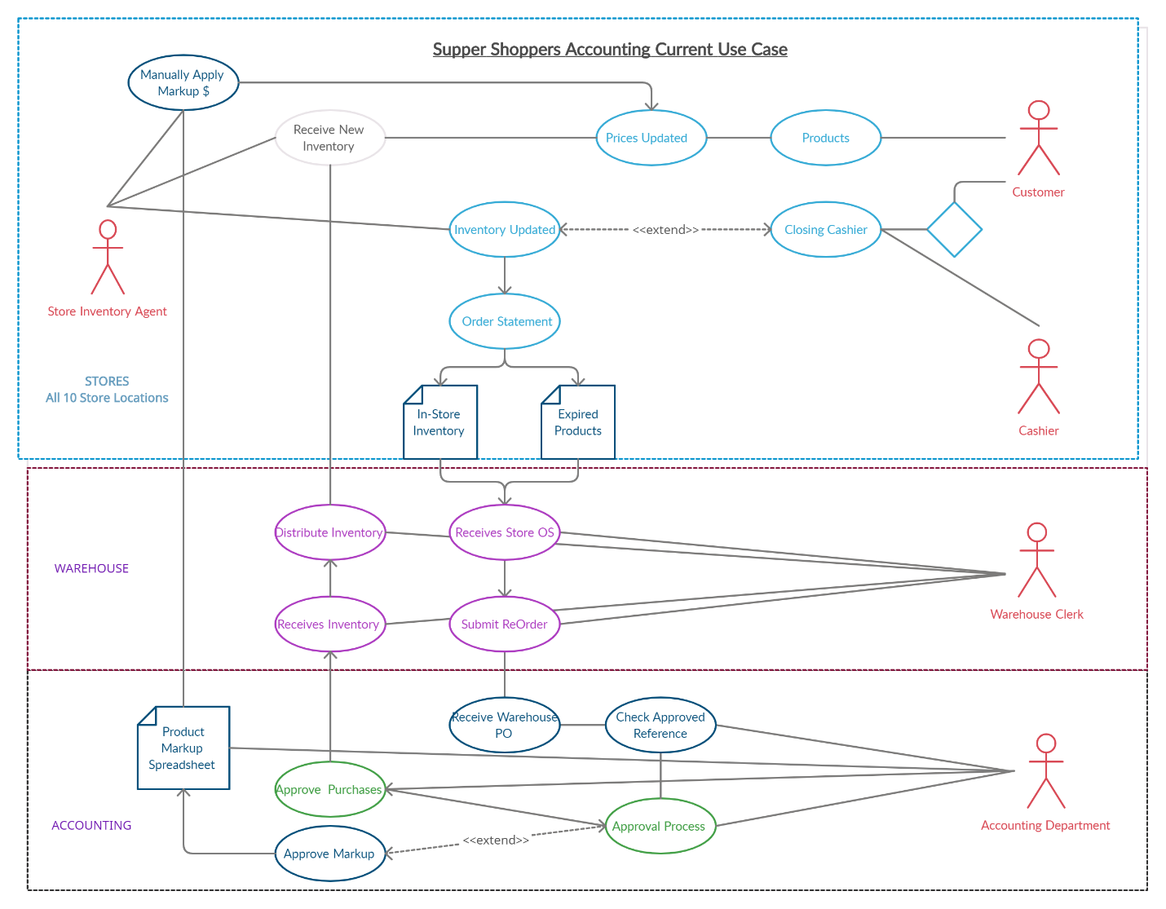

**Critical Issues:**

* Accounting approval process implements limitations and allotted time constraints that allow stock levels to fall, causing Stockouts in all stores due to longer procurement lead times and ineffective management systems.
* Longer lead time plus the lower reorder point stock procurement and the lower single point orders which are on average 5-10 products per order, per product, per store are to low. essentially conflicting with the order up to level (T,S) system currently in place.
* The inventory management of the company is followed and maintained at a 99% fill rate. Which needs to reevaluate (SS) Safety Stock levels of inventory needed to meet the fluctuations in demand.
* The company’s is currently using has a decentralized POS system. Each store which requires manual weekly warehouse record updates results as a point of failure due to human errors and possible miscalculations.
* The warehouse managers were asked to check the inventory manually. This presents another time constraint issue, when time required to track it down and the costs of the warehouse.
* warehouse managers are asked to manually update pricing on product through a spread sheet provided by accounting. This also causes time constraint issues on both ends.
* Warehouse has to manually enter price increase and margin data through a spreadsheet distributed to all the stores which is determined upon approval by accounting and presumably specific for each individual store location. None of the other departments know when they are getting this spreadsheet or if it will facilitate changes that are necessary in time given the current inventory in stock or the inventory needed.
* Not Implement Competitive Pricing and Price Matching Offers When a company is unable to anticipate competitor price changes or is not equipped to make corresponding changes in a timely fashion, a retailer may offer to match advertised competitor prices. This allows the retailer to maintain a competitive price point for those who become aware of the competitor's offer without having to officially change the price within the retailer’s point of sale system.

**Accounting Analysis:**

An Average Procurement lead time is 14 days (or 2 weeks) Supers hoppers Store seems to have a 2-4-week Procurement lead time on average.

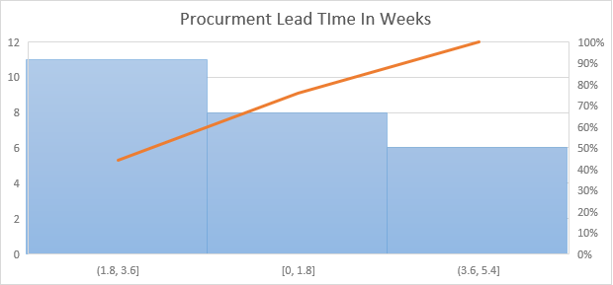

**Profit totals:**

For each store I counted the amount of stock missing, stockouts, and calculated the margins for each individual product and then multiplied that amount by the number of products sold for 8-week period of time. The total profit for all stores combine was $4633.00 in total

**Stockouts:**

I calculated stockouts for each individual store to get running totals. By calculating the amount of time (weeks) inventory was zeroed out and consecutive. This will show in weeks how often products where no longer in stock awaiting on inventory.

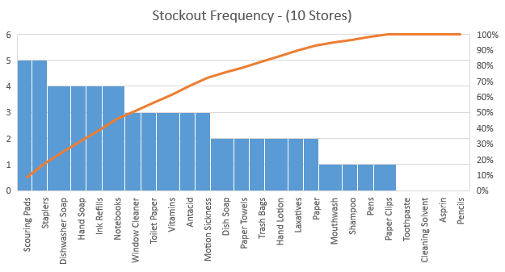

The data shows that **467** times, over the past 8 weeks across all 10 stores total where out of stock or had no inventory for that week less than or greater than 5 units on hand.



The data shows that the overall margin percentage for each product over 8-week period of time is consistent of only **20%** per product. This is a bad practice due to sale rate of individual products is not being taken into consideration. For example, lowering product pricing and offering discounts on best selling items have show to sell more products on average increasing the profit margin up to 30-60%. Whereas increasing this profit margin on products that do not sell can help recover loss from sales, stock, inventory expiration, and other factors.

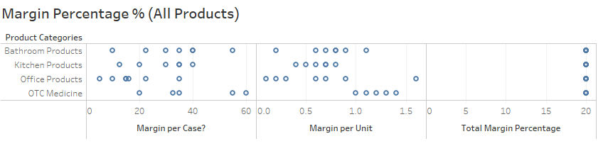

**Applied 20% Margin per 50 units:**

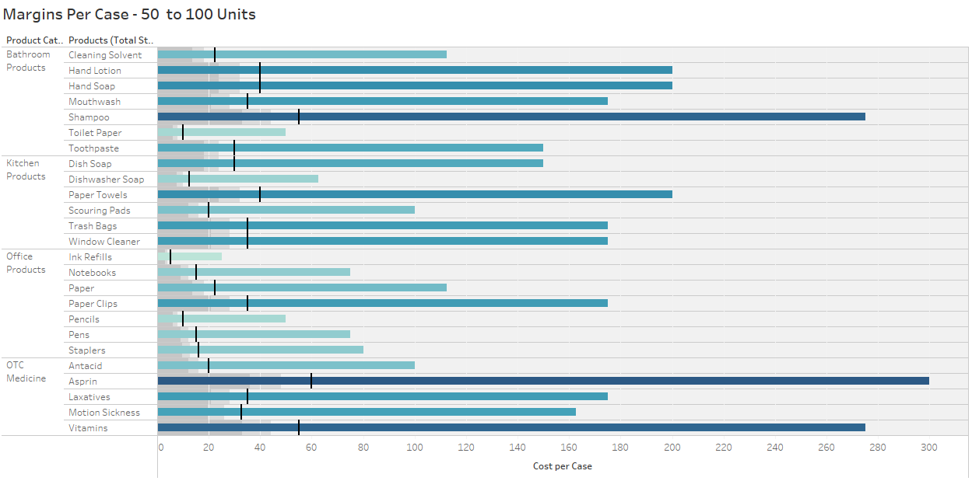

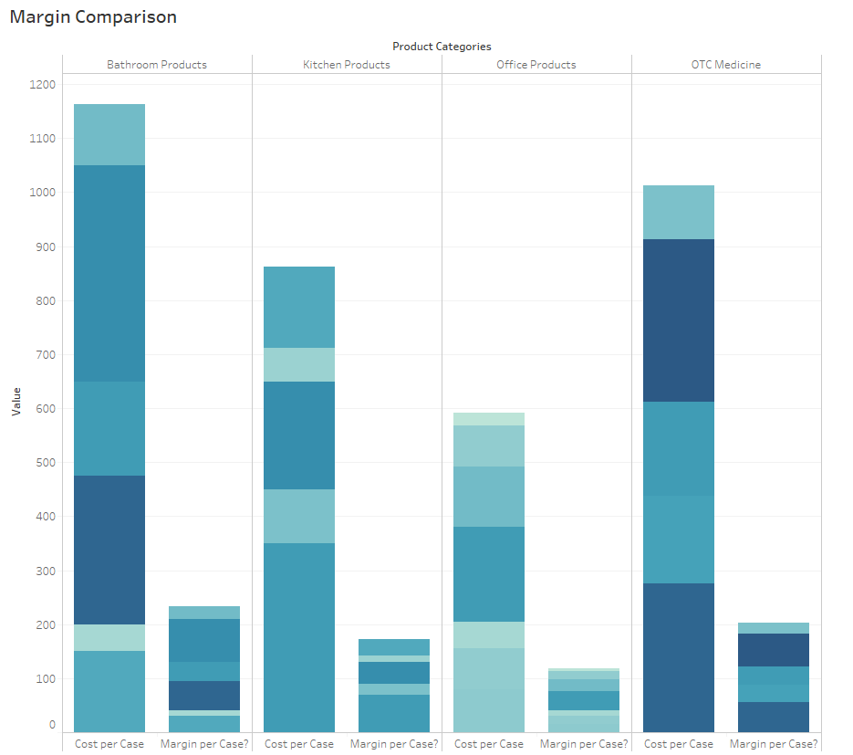

**Sell-through rate** is a calculation that is used to measure the amount of product received from Super Shoppers manufacturer against the amount of product sold to your customers in a specified period of time. To calculate it, using the total sales and divide that number by the stock on hand. Multiply this number by 100 to convert it to a percentage. This is an estimate not an exact figure based on the estimated values sold by each store with 95% confidence. This shows us how our demand for sales is not being met due to lack of inventory.

**STR -Conclusion:** the data supports the hypothesis that Increasing inventory and lowering reorder point to stock items faster could meet the demand and increase overall profit in all stores.

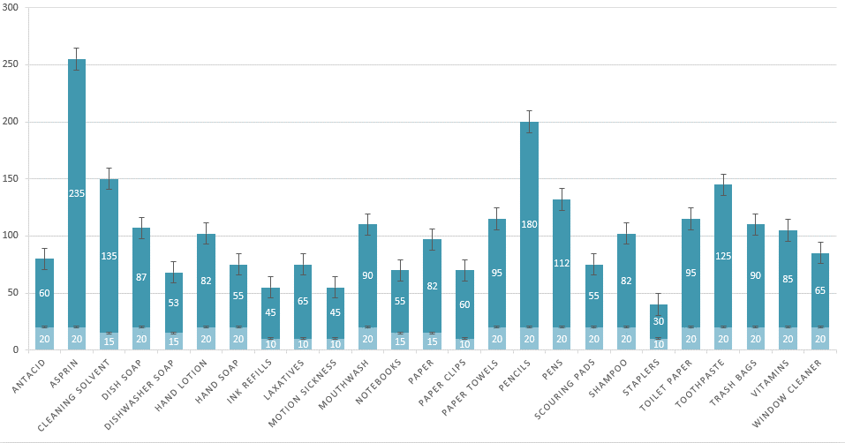

**Number of Stockouts (OOS) Per Store:** Counting the amount of times stock was at 0 per week per store for 8-wwek period of time averaged 2month period by 365 days in a year.

**Cycle Service Level** is a calculation used to determine the proper safety stock levels. Safety stock levels. With the analysis we can see if the warehouse is stocking enough or to much of a product which results in profit loss. Safety stock (SS) is an additional amount of inventory that is carried to meet fluctuations in demand. Safety stock helps reduce the probability of stockout

**Recommended Accounting Metrics Needed:**

These are additional recommended metrics Supper Shoppers company should consider. More data is needed to make accurate full analysis.

* **Sales velocity** is a way to measure how fast Super Shoppers products sell when they are available to thier customers.
* **Inventory Turnover** is a measure of how often a business sells through its entire inventory in a set period of time (often a year).
* **Carrying Cost** percentage is important for calculating the profit you’re making on your inventory.
* **Capital Cost** is the largest component of carrying cost incurred by businesses.
* **Inventory Service** **Cost** includes IT hardware, applications, tax, and insurance.
* **Inventory Risk Costs** include the shrinkage of inventory (which refers to the loss of products because of factors other than sale), theft, and administrative errors (such as misplaced goods, errors in shipping, or late system updates).
* **Storage Space Cost** includes the rent paid to warehouse your products, air conditioning and heating, lighting, transportation, and other costs associated with the physical warehouse.
* **Return on investment (ROI)** is a ratio used to determine a business’s profitability.

**Recommendations:**

Based on the current analysis, I feel these recommendations listed below are in good order to facilitate proper inventory managements, systems process, and best practices. That will be effective to regain lost time, being more profitable, and more dynamic .

* Centralizing the Warehousing & Server capabilities: The company can start a new a centralized warehouse and network infrastructure to remove independent server which all act as a point of failure when they are distributed. Implement this solution near the manufacturing site at the main warehouse to serve purchase and customer orders (Mittal, 2020).
* Implementing multiple warehouses from east to west or north to south allowing supper Shoppers company the ability to pull orders in a distributed manner separately adjusting the supply chain of products to all its demand.
* Offer Competitive Pricing and Price Matching Offers The data shows that base rate and single inventory amounts are only shipped to store at rates of 5-10 products per cycle. Increasing the stock amount and decreasing reorder points would allot for maximum feasibility (Mittal, 2020).
* ABC Analytics Minimum and Maximum Levels with Reorder Features such as auto Ordering and Order Cycles, top and Bottom Seller Identification, cloud Inventory Management.
* Verify all receivables with packing slips and Purchase Orders through digital cloud-based technology as a payment basis for the accounts payable office. Also, coordinate a daily campus and off campus distribution system.
* Training staff to use the technology and inventory management techniques. Such as lean process, scheduled meetings, establishing KPI’s Categorize Your Inventory Using ABC Analysis hierarchy, Implement Reorder Point Formulas, Just-in-time system, or Kanban system *(DEAR Systems, 2017), (Systems, 2017)*
* Create efficient Stock Order Cycles and Automatic Ordering -A great point of sale solution can also create recurring order cycles for each individual product. Again, these can be manually updated, but the software identifies the ordering pattern and automatically requests the new order according to the cycle. Once implemented, it’s completed entirely by your POS.
* Real-Time Inventory Management - Implement a cloud-based POS solution, all inventory updates are made immediately upon an order, delivery, sale, or return. This ensures that inventory count is accurate, and never out of stock. This will also help to facilitate the accrued time loss from stores having to wait on a spreadsheet from accounting assuming the rigorous accounting approval process (Naddor, 1966).
* Training staff to use the technology and inventory management tools. Such as (SAM) Software Asset Management Software *(Gartner Peer Insights, 2020).*
* Implement vendor outsourcing would also be a feasible option due to the following: parameters:
  + Lower Inventory Cost.
  + Less Warehousing operation expenses.
  + Managed inventory is the most important task.
  + Optimize the fill rate at lower cost.
* Implement Continuous Review, Fixed Order Quantity (s, Q) System implements inventory position of an item is monitored continuously and is known at all times. Inventory position of an item is defined as the number of items held currently in stock plus the number of items on order (Mittal, 2020). As demand arises, items are withdrawn from inventory. Simultaneously, the inventory position is updated. This process continues until the inventory level reaches a predetermined level, s, referred to as the reorder point. At this point, anew replenishment order of size Q is placed, which is filled after time L, referred to as the lead time. Receipt of the order increases the inventory position. The process of order-point, order-quantity system as depicted below *(Chopra, 2010).*

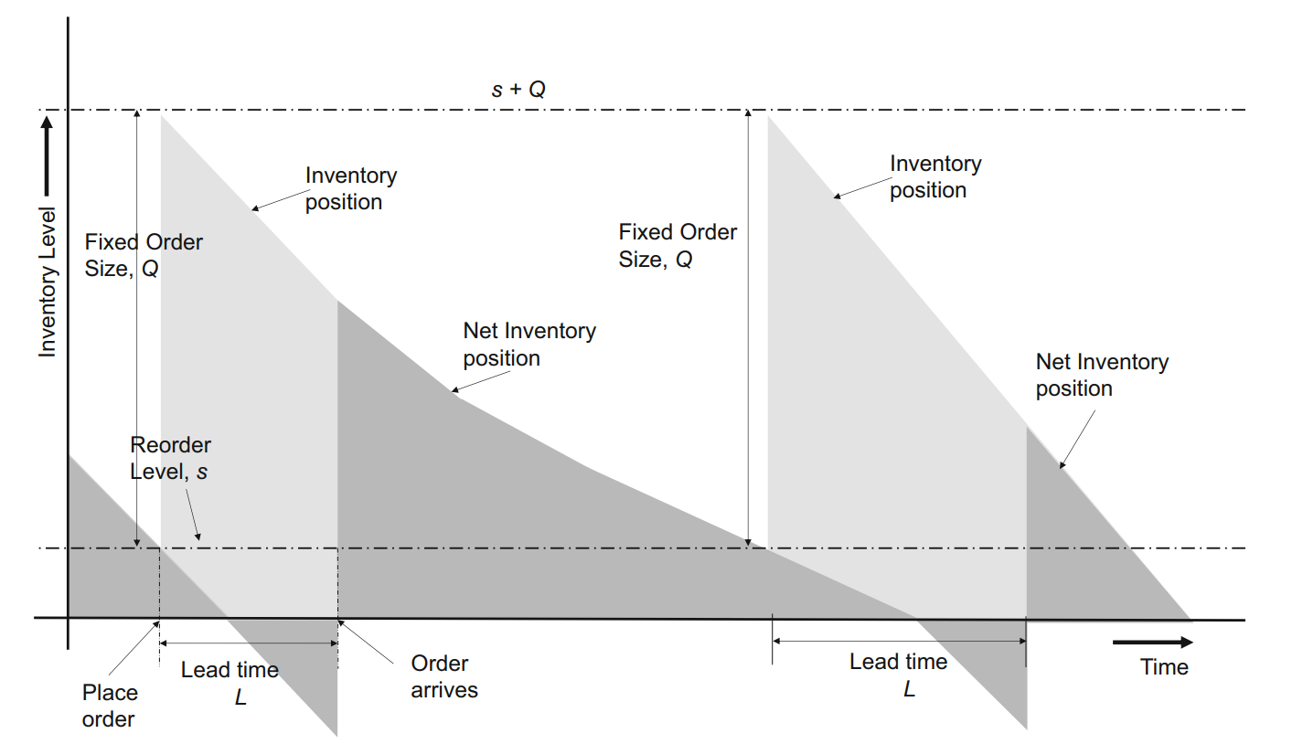

* Implement the following inventory management and control system models on the frequency basis of EOQs, CI, Fill rate and other suggested metrics for single and multiple inventory items such as:
  + Instantaneous Supply Model (ISM)
  + Dynamic Inventory Control
  + Stochastic Inventory Models
  + Multi- Inventory Models
  + Selective Inventory Models

# References

5S Today. (2020). *What is 5S?* Retrieved from https://www.5stoday.com: https://www.5stoday.com/what-is-5s/

Chopra, S. &. (2010). *Supply chain management – strategy, planning and operation.* New Jersey: Pearson Education, Inc.

DEAR Systems. (2017, Aug 05). *What is a Reorder Point Formula and How is it Calculated?* Retrieved from https://dearsystems.com: https://dearsystems.com/reorder-point-formula/

Fdm4. (2020, Nov 25). *HOW TO ORGANIZE WAREHOUSE INVENTORY*. Retrieved from www.fdm4.com: https://www.fdm4.com/how-to-organize-warehouse-inventory/

Gartner Peer Insights. (2020). *Software Asset Management (SAM) Tools Reviews and Ratings*. Retrieved from https://www.gartner.com: https://www.gartner.com/reviews/market/software-asset-management-tools

Mittal, N. H. (2020). *Optimization and Inventory.* Singapore: Springer Nature.

Naddor, E. (1966). *Inventory systems.* New York: Wiley.

Systems, D. (2017, Nov 17). *10 Inventory Management Best Practices for Improving Your Business*. Retrieved from https://dearsystems.com: https://dearsystems.com/inventory-management-best-practices/